**Dr. Peggy Kern’s Capstone Statistics**

**Practice #2: The Normal Distribution & Z Scores**

*Statistics are learned best by doing! Here is a set of exercises to let you practice what we have covered on the Normal distribution and Z scores. See if you can work through them before checking your responses.*

1. Probability values range from ________ to _________.
2. What is the difference between an empirical and probability distribution?
3. Below is part of a normal distribution table[1]:

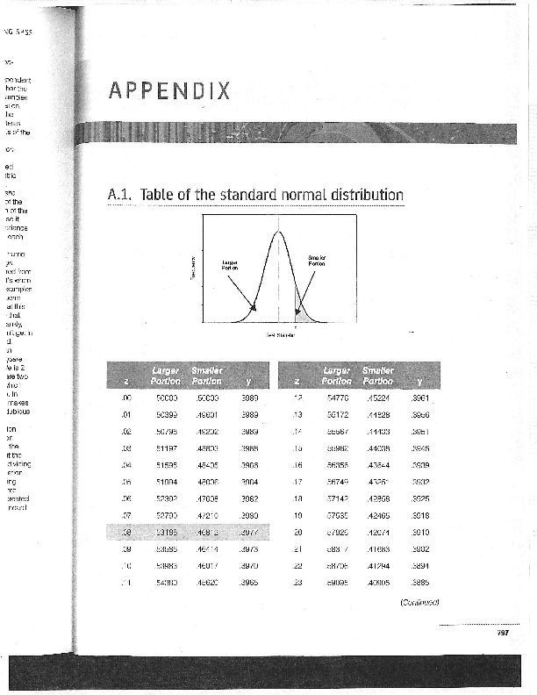 

* 1. What does the first column (z) refer to?
  2. What does the second column (larger portion) refer to?
  3. What does the third column (smaller portion) refer to?

1. The standard normal distribution (Z distribution) is a probability distribution with a mean of 0 and a standard deviation of 1. We can compare raw scores from different scales by converting them to Z scores (that is, standardizing the values). Recall that **z = (X-M)/s** (where **X** = the score, **M** is the mean of the sample, and **s** is the standard deviation.
   1. Suppose a population was normally distributed with a mean of 10 and standard deviation of 2. What proportion of the scores are below 12.5?
   2. Let’s say that the average IQ of a group of people is 105 with a standard deviation of 15. What is the standardized (or z- score) of someone:
      1. with an IQ of 93?
      2. with an IQ of 135?
   3. One year, many college-bound high school seniors in the U.S. took the Scholastic Aptitude Test (SAT). For the verbal portion of this test, the mean was 425 and the standard deviation was 110. Based on this information what percentage of students would be expected to score between 350 and 550?
2. At Hogwarts School of Witchcraft and Wizardry, Professor Snape was concerned about grade inflation, and suggested that the school should issue standardized grades (or z-scores), in addition to the regular grades. How might this work? Harry was in four classes, each with 20 students. Harry’s score, the class mean, and the class standard deviation are given below. Compute his standardized grade in each class. If we judged by standardized grades, where did he do best? Where did he do worst?

Harry’s Score Mean Std Dev

Care of Magical Creatures 3.80 3.75 .15

Defense Against the Dark Arts 3.60 3.25 .60

Transfiguration 3.10 3.20 .38

Potions 2.50 2.90 .75

1. When the original Star Wars movie came out (1977), there was much excitement about the movie. Here are some classic problems that were considered soon after.
2. On the average, it takes Han Solo 45 seconds to check the coordinates and make the jump into hyperspace. The standard deviation on this important task is 5 seconds. When Han and Chewbacca and their passengers are leaving for Alderaan they make the jump in 33 seconds or less. What is the probability of such an accomplishment?
3. In a space bar, there were 14 storm troopers, 3 Wookies, 9 humans, and 2 scriptwriters. An Android entered, fired a shot, and hit someone in the cheek. What is the probability that a scriptwriter was hit?
4. Jawas, those jewel-eyes, hooded collectors of robots and scrap, live in the desert and travel by sandcrawler. Their height is normally distributed with a mean of four feet and a standard deviation of 3 inches. The escape exit on the sandcrawler is 46 inches high. What proportion of the Jawas must duck when they use the escape exit?

1. From Appendix A, Field, A. (2009). *Introducing statistics using SPSS* (3rd ed.). London: Sage Publications. This is one version of such a table, which indicates both the area above and below a score. Other versions of the tables often only indicate the lower portion, still others indicate the upper portion. Some give both positive and negative Z scores, some only include positive values (remember that the normal distribution is symmetrical. This can make it confusing to consider what to look at. Drawing a diagram helps. It also might be helpful to try some different tables and find the one that makes the most sense to you. The [Math is Fun website](http://www.mathsisfun.com/data/standard-normal-distribution-table.html) gives one option, but there are many others out there as well.